**KENDRIYA VIDYALAYA SANGATHAN, ZIET, MYSORE**

**SUMMATIVE ASSESMENT -2**

Class: v Max.V.P : 60.

Sub: Evs Time: 2 ½ hrs.

Name-----------------------------------------------Roll.no.----------------------------

Signature of the Signature of the examiner

Invigilator

**ENVIRONMENTAL SENSITIVITY** :

1. [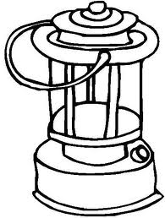](http://www.google.co.in/imgres?imgurl=http://0.tqn.com/d/familycrafts/1/0/O/6/3/Color_Lantern.jpg&imgrefurl=http://familycrafts.about.com/od/campingandpicniccrafts/ss/Lantern_Coloring_Book_Page.htm&usg=__wZ91TyUC6tEjpQmN10HZGpQBSO4=&h=567&w=429&sz=39&hl=en&start=0&zoom=1&tbnid=2sHtH8-b1OwtqM:&tbnh=119&tbnw=91&ei=NexbTeOGL4vevQO62PHbDA&prev=/images?q=colouring+book+lantern&hl=en&sa=G&biw=1362&bih=542&gbv=2&tbs=isch:1&itbs=1&iact=hc&vpx=114&vpy=71&dur=4149&hovh=258&hovw=195&tx=122&ty=124&oei=_utbTZa1IIf5cc2QtawK&page=1&ndsp=30&ved=1t:429,r:0,s:0)OBSERVATION: [](http://www.google.co.in/imgres?imgurl=http://0.tqn.com/d/familycrafts/1/0/O/6/3/Color_Lantern.jpg&imgrefurl=http://familycrafts.about.com/od/campingandpicniccrafts/ss/Lantern_Coloring_Book_Page.htm&usg=__wZ91TyUC6tEjpQmN10HZGpQBSO4=&h=567&w=429&sz=39&hl=en&start=0&zoom=1&tbnid=2sHtH8-b1OwtqM:&tbnh=119&tbnw=91&ei=NexbTeOGL4vevQO62PHbDA&prev=/images?q=colouring+book+lantern&hl=en&sa=G&biw=1362&bih=542&gbv=2&tbs=isch:1&itbs=1&iact=hc&vpx=114&vpy=67&dur=125&hovh=258&hovw=195&tx=108&ty=130&oei=_utbTZa1IIf5cc2QtawK&page=1&ndsp=30&ved=1t:429,r:0,s:0)[](http://www.google.co.in/imgres?imgurl=http://0.tqn.com/d/familycrafts/1/0/O/6/3/Color_Lantern.jpg&imgrefurl=http://familycrafts.about.com/od/campingandpicniccrafts/ss/Lantern_Coloring_Book_Page.htm&usg=__wZ91TyUC6tEjpQmN10HZGpQBSO4=&h=567&w=429&sz=39&hl=en&start=0&zoom=1&tbnid=2sHtH8-b1OwtqM:&tbnh=119&tbnw=91&ei=NexbTeOGL4vevQO62PHbDA&prev=/images?q=colouring+book+lantern&hl=en&sa=G&biw=1362&bih=542&gbv=2&tbs=isch:1&itbs=1&iact=hc&vpx=114&vpy=71&dur=2683&hovh=258&hovw=195&tx=128&ty=156&oei=_utbTZa1IIf5cc2QtawK&page=1&ndsp=30&ved=1t:429,r:0,s:0)
2. [](http://www.google.co.in/imgres?imgurl=http://0.tqn.com/d/familycrafts/1/0/O/6/3/Color_Lantern.jpg&imgrefurl=http://familycrafts.about.com/od/campingandpicniccrafts/ss/Lantern_Coloring_Book_Page.htm&usg=__wZ91TyUC6tEjpQmN10HZGpQBSO4=&h=567&w=429&sz=39&hl=en&start=0&zoom=1&tbnid=2sHtH8-b1OwtqM:&tbnh=119&tbnw=91&ei=NexbTeOGL4vevQO62PHbDA&prev=/images?q=colouring+book+lantern&hl=en&sa=G&biw=1362&bih=542&gbv=2&tbs=isch:1&itbs=1&iact=hc&vpx=114&vpy=67&dur=125&hovh=258&hovw=195&tx=108&ty=130&oei=_utbTZa1IIf5cc2QtawK&page=1&ndsp=30&ved=1t:429,r:0,s:0)
3. **Answer all questions**

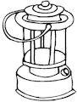 [](http://www.google.co.in/imgres?imgurl=http://0.tqn.com/d/familycrafts/1/0/O/6/3/Color_Lantern.jpg&imgrefurl=http://familycrafts.about.com/od/campingandpicniccrafts/ss/Lantern_Coloring_Book_Page.htm&usg=__wZ91TyUC6tEjpQmN10HZGpQBSO4=&h=567&w=429&sz=39&hl=en&start=0&zoom=1&tbnid=2sHtH8-b1OwtqM:&tbnh=119&tbnw=91&ei=NexbTeOGL4vevQO62PHbDA&prev=/images?q=colouring+book+lantern&hl=en&sa=G&biw=1362&bih=542&gbv=2&tbs=isch:1&itbs=1&iact=hc&vpx=114&vpy=67&dur=125&hovh=258&hovw=195&tx=108&ty=130&oei=_utbTZa1IIf5cc2QtawK&page=1&ndsp=30&ved=1t:429,r:0,s:0)

1. What is this?

…………………… …………….[](http://www.google.co.in/imgres?imgurl=http://0.tqn.com/d/familycrafts/1/0/O/6/3/Color_Lantern.jpg&imgrefurl=http://familycrafts.about.com/od/campingandpicniccrafts/ss/Lantern_Coloring_Book_Page.htm&usg=__wZ91TyUC6tEjpQmN10HZGpQBSO4=&h=567&w=429&sz=39&hl=en&start=0&zoom=1&tbnid=2sHtH8-b1OwtqM:&tbnh=119&tbnw=91&ei=NexbTeOGL4vevQO62PHbDA&prev=/images?q=colouring+book+lantern&hl=en&sa=G&biw=1362&bih=542&gbv=2&tbs=isch:1&itbs=1&iact=hc&vpx=114&vpy=71&dur=2683&hovh=258&hovw=195&tx=128&ty=156&oei=_utbTZa1IIf5cc2QtawK&page=1&ndsp=30&ved=1t:429,r:0,s:0)

b) Which fuel is used in it?

……………………………………

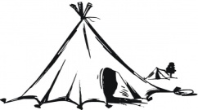[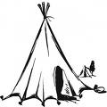](http://www.google.co.in/imgres?imgurl=http://www.supercoloring.com/wp-content/main/2009_06/nomads-tent-coloring-page.jpg&imgrefurl=http://www.supercoloring.com/pages/nomads-tent/&usg=__eidGQdDYJ0XC-ejejkQqaUHktkk=&h=350&w=350&sz=32&hl=en&start=0&zoom=0&tbnid=To1IPuLX_XkYHM:&tbnh=120&tbnw=120&ei=sPFbTeG0GIL8vQO6oNjsDA&prev=/images?q=tent+colouring+book&hl=en&sa=G&biw=1362&bih=542&gbv=2&tbs=isch:1&itbs=1&iact=hc&vpx=885&vpy=104&dur=1826&hovh=120&hovw=120&tx=81&ty=82&oei=k_FbTY3GBdzccLSpkaUK&page=1&ndsp=23&ved=1t:429,r:5,s:0)[](http://www.google.co.in/imgres?imgurl=http://www.supercoloring.com/wp-content/main/2009_06/nomads-tent-coloring-page.jpg&imgrefurl=http://www.supercoloring.com/pages/nomads-tent/&usg=__eidGQdDYJ0XC-ejejkQqaUHktkk=&h=350&w=350&sz=32&hl=en&start=0&zoom=0&tbnid=To1IPuLX_XkYHM:&tbnh=120&tbnw=120&ei=sPFbTeG0GIL8vQO6oNjsDA&prev=/images?q=tent+colouring+book&hl=en&sa=G&biw=1362&bih=542&gbv=2&tbs=isch:1&itbs=1&iact=hc&vpx=885&vpy=104&dur=4602&hovh=120&hovw=120&tx=82&ty=54&oei=k_FbTY3GBdzccLSpkaUK&page=1&ndsp=23&ved=1t:429,r:5,s:0)[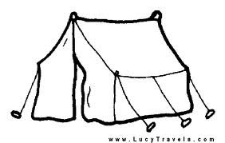](http://www.google.co.in/imgres?imgurl=http://www.lucytravels.com/images/camping-coloring-pages-1.gif&imgrefurl=http://pcupgraderesource.com/lg/yf-printable-coloring-rv-tent.htm&usg=__z-XPJAkDbFJjby_I0Hqyfkqxe_Y=&h=346&w=544&sz=5&hl=en&start=0&zoom=1&tbnid=pDRctTsWcdizTM:&tbnh=105&tbnw=165&ei=sPFbTeG0GIL8vQO6oNjsDA&prev=/images?q=tent+colouring+book&hl=en&sa=G&biw=1362&bih=542&gbv=2&tbs=isch:1&itbs=1&iact=hc&vpx=220&vpy=223&dur=2558&hovh=179&hovw=282&tx=144&ty=73&oei=k_FbTY3GBdzccLSpkaUK&page=1&ndsp=23&ved=1t:429,r:9,s:0)

2. What type of house is it?

………………………………………………….

Where do you find such houses?

………………………………………………

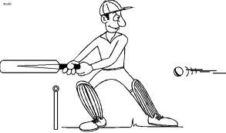[](http://www.google.co.in/imgres?imgurl=http://www.4to40.com/images/Coloring_Book/Batsman.gif&imgrefurl=http://www.4to40.com/coloring_designs_patterns/print.asp?id=1221&usg=__RTpOY534Zx0wxniYM4_rK_8seBo=&h=471&w=800&sz=29&hl=en&start=81&zoom=1&tbnid=d58-BvGD7URUXM:&tbnh=92&tbnw=157&ei=XfRbTZS-GYGqvQPIu7SFCA&prev=/images?q=cricket+colouring+book&hl=en&biw=1362&bih=542&gbv=2&tbs=isch:1&itbs=1&iact=hc&vpx=558&vpy=241&dur=1887&hovh=172&hovw=293&tx=154&ty=74&oei=N_RbTZCGM4mxcfzipbYK&page=4&ndsp=27&ved=1t:429,r:13,s:81)

3. How many players will be there in this game?

………………………………………………

Who is your favourite player?

………………………………………………..

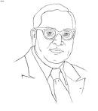

4. Who is he?

……………………………………………….

What change did he bring in the society?

……………………………………………………………..

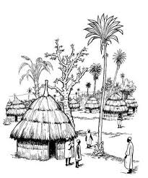

5. What is it?

………………………………………..

Write two sentences about it

……………………………………............

…………………………………………………

1. **Match the following correctly**

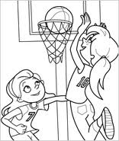 People were asked to leave the place to make it

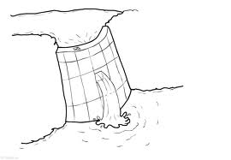 seeds can be stored in its shell

 girls created a change by playing thisgame

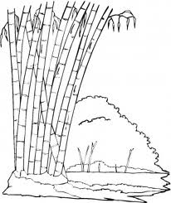 They look exactly alike

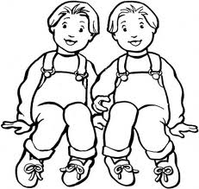

Adivasis use this tree to make cups

ANSWER IN ONE WORD

1. Name one disease which can be passed on from parents to the child.

Ans……………………………..

1. Who is the girl star in the “PROJECT GIRL STAR”

Ans………………………………………………………

3.Name one preservative used to store the seeds.

Ans……………………………………………………………………..

4.Write one problem which people usually face when they are asked

to shift from one place to other.

Ans……………………………………………………………………………

5. what job do you like to take up when you grow up?

Ans………………………………………………………………………………

Identification : Answer in short

1. Suggest two ways to save petrol.

Ans……………………………………………………………………………………

…………………………………………………………………………………………

2.What type of houses are found in Kashmir?

Ans………………………………………………………………………………………………

………………………………………………………………………………………………………………..

3.What are man- made disasters? Name any two such disasters.

Ans………………………………………………………………………………………………

4.Why does your heart beat increase when you run fast? Ans………………………………………………………………………………………

5. compare modern and Traditional methods of farming

|  |  |
| --- | --- |
| Modern farming | Traditional farming |

CHOOSE THE RIGHT ANSWER

1. Anyone who encourages the Child-labour will be
2. Punished ( b) rewarded (c) made labour ( d) ignored
3. Pulse polio programme is to eradicate this disease .

a)Cancer (b) B.P (c) Polio (d) Blindness

1. The other name for forest in Kuduk language is
2. Dance (b) snake (c) Song ( d) Torang.
3. Babies who are born together and look exactly alike are known as

a)Twins ( b) Identical twins (c) Joined twins (d) copies

5 . On this day people plant saplings and eat in the gardens.

a) Vanmahotsav day ( b) children’s day (c) teacher’s day (d) Annual day

6. Which is a natural fertilizer?

1. Ammonia (b) Nitrogen (c) chlorine (d) cow dung

7.If farmers use chemicals the soil becomes

a)Barren (b) loose (c) soft (d) slippery.

8. Which game does Gutta Jwala play?

a)basket ball (b) Tennis (c) cricket (d) Kho-Kho

9. When the lung is expanded it is as long as a

a) pencil (b) scale (c) table (d) foot ball ground.

10. We play this instrument by blowing air.

a) Tabla (b) Bongo (c) Guitar (d) Mouthorgan.

C. SKILL

i) Draw the following pictures colour and label them.

1. Jhoom farming

2. Ambulance brought at the earthquake sight

3. Solar water heater

4.One seed storage container

1. One product made by adiwasis

ii) Show the following places in the map and colour the states in which you find these places.

1.Mumbai 2. Rajamundry 3. Kashmir 4. Bhuj 5. Jharkhand. Mark the seas and label

